**ANESTHESIA TECHNICIAN DAY 2019**

**1st April 2019**

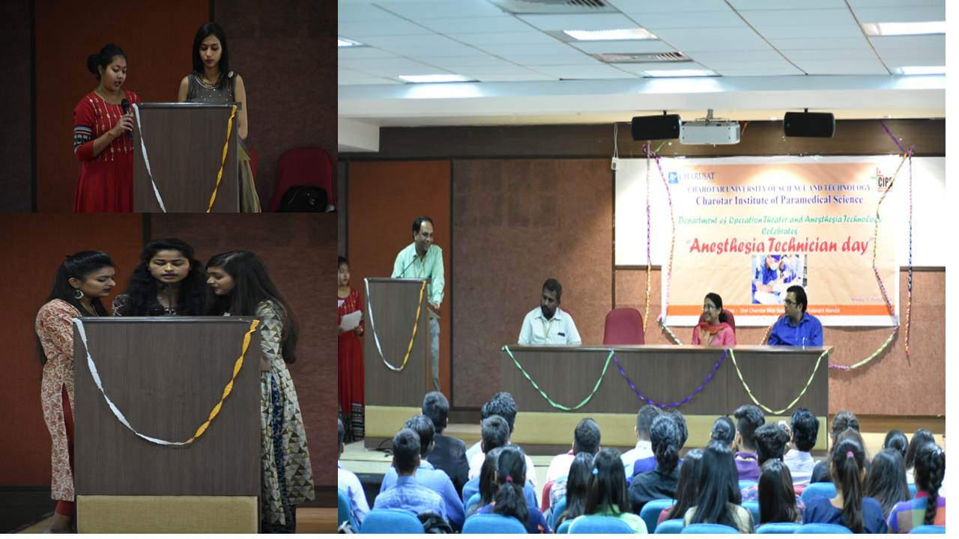

Figure Students and Dr.Darshan Patel, Principle of CIPS welcoming Dr. Hemlata Kamat

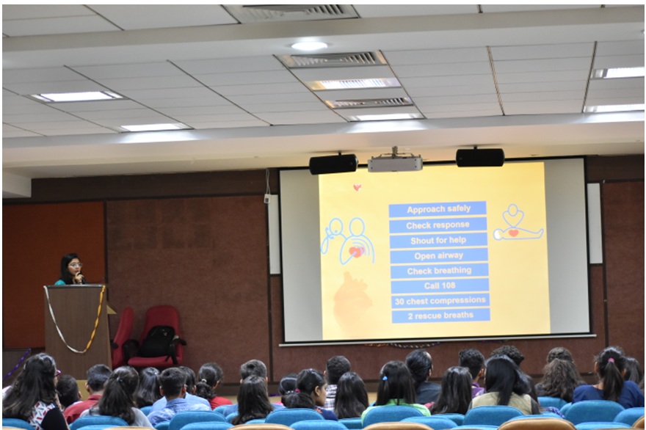

Figure Students Start with Presentations

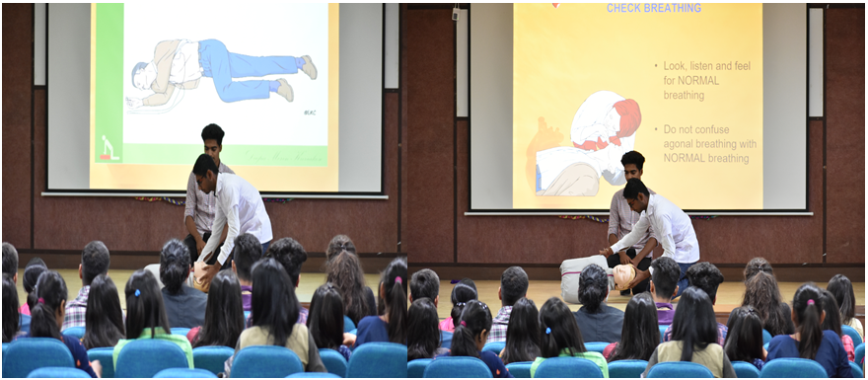

Figure Final Year students performing CPR

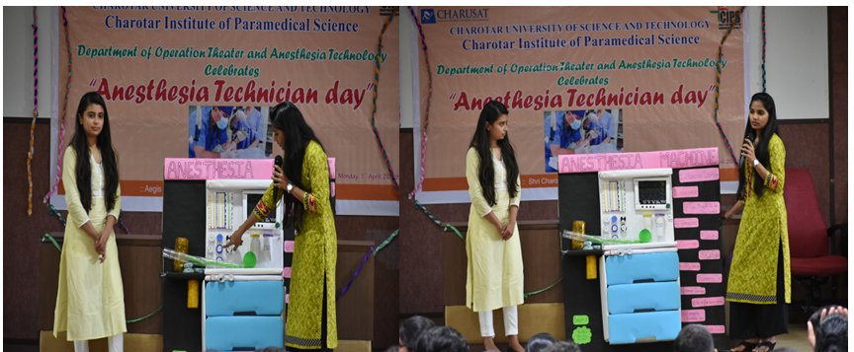

Figure Students presenting their anaesthesia models made by themselves

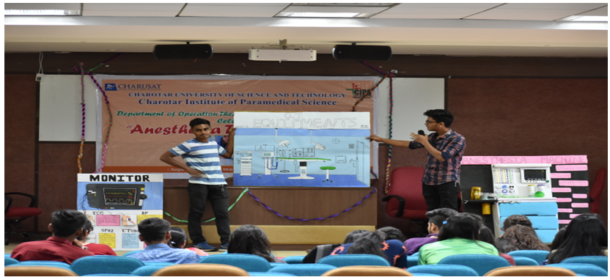

Figure Students participating in poster presentation



Figure Dr. Hemlata Kamat explaining the students about CPR

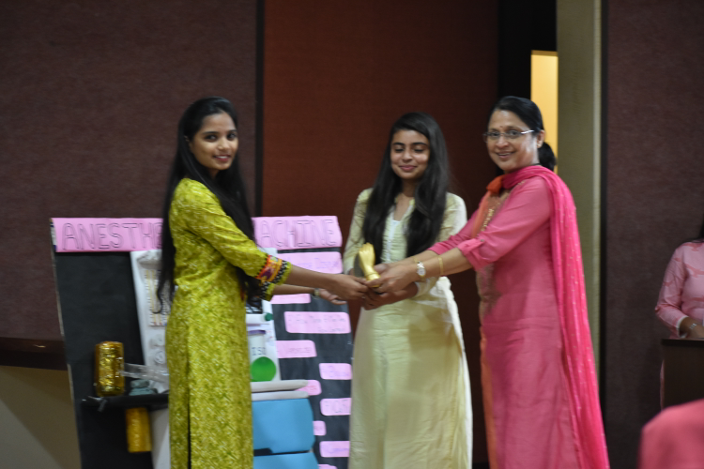

Figure Dr. Hemlata Kamat awarding the winners